 Name__________________

Year 11

2021

Attitudes Investigation

10%

**Conduct an original research investigation into attitudes.**

**Score: /50**

Top of Form

**Conduct an original research investigation into attitudes.**

**Year 11 Psychology students must design and conduct an original research investigation into attitudes. This assignment also requires students to analyse data and critically evaluate the results.**

**Choose a topic on which you can set a survey that you can use to show individual attitudes. Use the example below as a guide as to what is expected.**

**We will collate the questions and send out a single questionnaire to all participants. A consent form will be required and handed out with the survey.**

**Conditions**

Time for the task:

* Two weeks to plan survey questions, conduct the investigation, collect the data and research studies about the attitude topic.
* During this time you will write up your method, table, graph and briefly summarise your results as per the report requirements.
* One period (Monday week 10) to write the abstract, introdution, discussion and conclusion under test conditions.

Materials required when writing the Abstract, Introduction, Discussion and Conclusion:

* method
* results section – including data (tables and graphs)
* list of references
* a half-A4 page of notes, size 11 Calibri or Times New Roman, **must be dot points**

You must also consider how you will address the ethics involved in any investigation.

**Due date: Monday Week 10 (20 Sep 21) Total Mark: / 50**

Example: (You may NOT use this topic) *note – this was presented as a poster but you are to complete a lab report)

Youth and Parental Attitudes Towards the Use of Social Media.

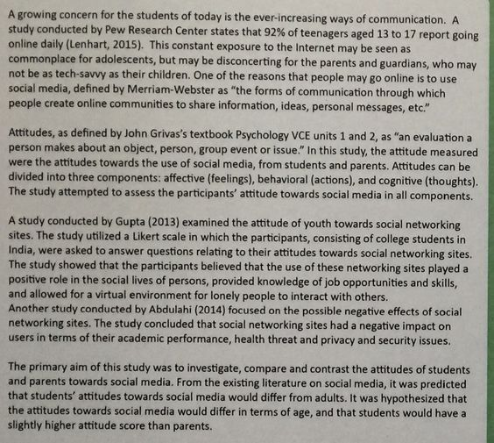

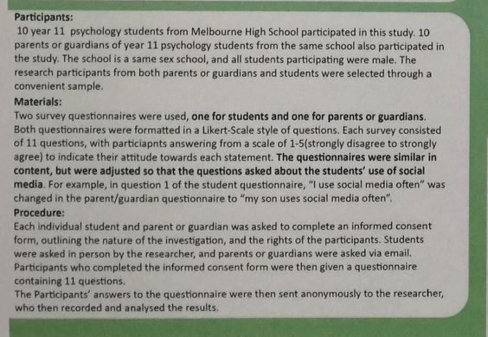

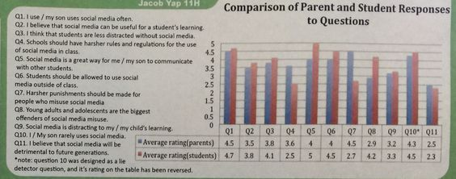

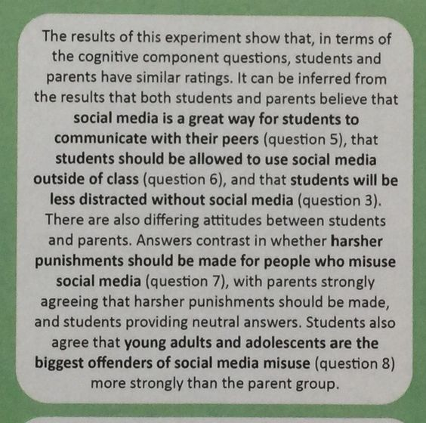

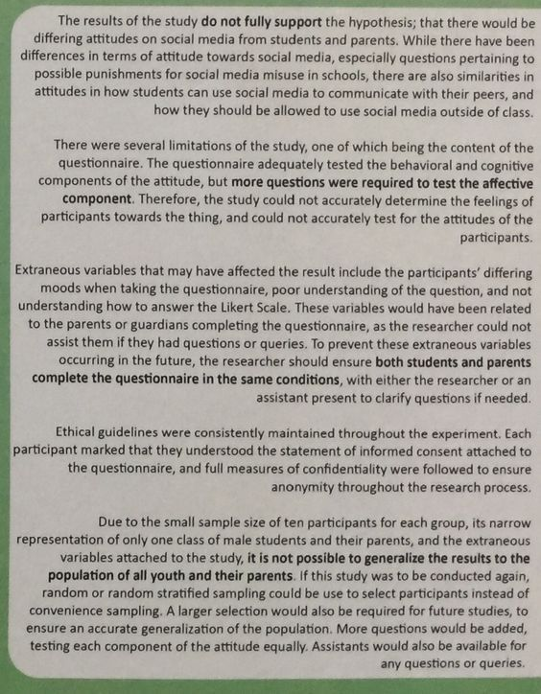

**Ideas for attitudes you may want to explore:**

* Driving age
* Organ donation
* Single use plastic
* Eating meat
* Travel
* Marriage/Divorce
* fast food
* underage drinking
* learning a second language
* homework
* Homelessness
* career pathways
* Charity/donations
* Asylum seekers and refugees
* peer pressure
* AFL
* compulsory school uniform
* profanity
* Politics
* Makeup

**Examples of possible relationships to investigate:**

The cause of homelessness on one’s attitudes towards the homeless

Attitudes towards gender stereotypes on career pathways

The effect of charity promotions on the public’s attitude towards donating

Attitudes towards asylum seekers and refugees based on immigrant generations

Investigation on the effect of gender on peer pressure

The effect of gender on attitudes towards AFL

An investigation of attitudes towards compulsory school uniform in male and female adolescence

The effect of headlines on attitudes

Attitudes towards profanity

An investigation into attitudes towards politics based on gender

The effect of gender on attitudes towards fast food

Attitudes towards underage drinking

Attitudes towards learning a second language

Attitudes towards Religious Education in Years 11 and 12

Attitudes towards voting for a political party

The effect of gender on attitudes towards homework

**Original Investigation on Attitudes**

**Marking key**

|  |  |
| --- | --- |
| **Description** | **Marks** |
| **Abstract** |  |
| * Succintly writes a specific aim | 2 |
| * Provides a general aim | 1 |
| * Briefly describes the method, including   Participants  Materials used  How the task was administered | 1 - 3 |
| * States the results of the research | 1 |
| * Draws a relevant conclusion | 1 |
| **Subtotal** | **7** |
| **Introduction** |  |
| * Makes a relevant statement about Attitudes | 2 |
| * Makes some comments about Attitudes | 1 |
| * Supports above information with reference to relevant research | 2 |
| * Refers to some research without making links to the topic | 1 |
| * Writes an operational hypothesis that follows on logically from the aim | 2 |
| * Poses a research question/prediction | 1 |
| **Subtotal** | **6** |
| **Method** |  |
| * describes participants in sufficient detail to be replicated, e.g. number, age, gender * describes the selection process | 1–2 |
| * describes materials in sufficient detail to be replicated | 1–2 |
| * describes the procedure including:   + addresses anonymity   + describes task in sufficient detail to be replicated   + describes the collection, collation and presentation of questionnaire results | 1–3 |
| **Subtotal** | **7** |
| **Results** |  |
| * organises all relevant data logically in correctly labelled tables   + correctly organises table   + correctly labels table including units where appropriate   + includes relevant data | 1–3 |
| * presents data in a graph * correctly graphs data * uses appropriate labelling * uses appropriate titles | 1–3 |
| * states results of the investigation * provides an accurate summary of the data | 1 - 2 |
| **Subtotal** | **8** |

Continued over page

|  |  |
| --- | --- |
| **Discussion** |  |
| * discusses the results of the investigation, relates the results to the hypothesis and explains how they relate to relevant psychological theories/research (which were introduced in the introduction) | 4 |
| * discusses the results of the research, comments on the hypothesis and describes relevant psychological theories | 3 |
| * describes what happened in the investigation and cites relevant psychological theories | 2 |
| * describes what happened in the investigation | 1 |
| * evaluates the investigation design:   + discusses any methodological flaws   + explains steps taken to ensure reliability and how it could be improved | 3 |
| * explains how variables were controlled and suggests ways to improve reliability | 2 |
| * states that variables need to be controlled and suggests how to improve reliability | 1 |
| * discusses ethical issues and describes how these were addressed | 2 |
| * refers to ethical issues that were considered in the investigation | 1 |
| * discusses relevance of results to the population from which the sample was drawn as well as to theory or other research referred to in the introduction | 2 |
| * suggests how the investigation might be of relevance to science or society | 1 |
| * makes accurate conclusions that relate to the hypothesis or research question | 2 |
| * forms an accurate conclusion but does not relate it to the hypothesis or research question | 1 |
| **Subtotal** | **13** |
| **References** |  |
| * includes a range of relevant references * includes some relevant references | 2  1 |
| * Correct end-text referencing (inc. listed alphabetically) | 1 |
| * Correct in-text referencing (inc. quantity) | 1 |
| **Subtotal** | **4** |
| **Appendix** |  |
| * appends data sheet (raw data) | 1 |
| **Subtotal** | **1** |
| **Clarity of expression** |  |
| * Quality of spelling and grammar | 1-2 |
| * Correct use of headings, organised, presented in APA format | 1 |
| * Written in passive voice | 1 |
| **Subtotal** | **4** |
| **Total** | **50** |